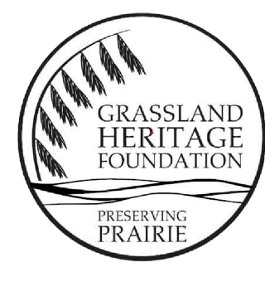
Grassland Heritage Foundation
Sustaining Prairies Fund
Grassland Heritage Foundation (GHF) preserves prairies in eastern Kansas through education, stewardship, and land protection. We are continuing our program that provides financial help for people who have created small prairie plantings or restorations at their school, church, or other publicly accessible location. Our funds can be used to assist with prairie management or use. See details below; note that we are particularly enthusiastic about our funds being used in such a way to increase the awareness and interest of young people to prairies.
Why are we developing this program? Our experience is that people embark on prairie plantings with great enthusiasm. But sometimes as years go by, these plantings are neglected or underused.
What types of sites are eligible for this program? Sites should have been predominantly planted with native prairie plants. These can be of various sizes, from small pollinator gardens to larger prairie restorations or reconstructions.
What types of activities would be appropriate for this funding? We invite applications that focus on one or both of the following areas:
- Prairie management. Weedy plants and/or shrubs and trees may colonize prairie plantings. We could provide funds to assist with removing unwanted weeds from a garden and provide education on continued management. For example, a teacher or mentor could create a simple prairie internship program and use our funds to buy tools for maintenance or provide rewards or compensations for students working in the prairie. Our funding could also be used to pay a conservation professional for advice on prairie management or to pay for a prairie burn.
- Prairie use. Prairie plantings can be underutilized. We could provide funds for creative ideas that increase use of prairie sites by young people. Teachers at a school with a large restoration, for example, bought jumpsuits and rubber boots for students, making it easier and more comfortable spending time inside the prairie. Curriculum development, signage, or funds to develop a “prairie day open house” could also fit in this category. Other options might be collecting nets, magnifiers, or reference books.
What are the details of the application procedure, amount of funding, and when will funds be available? See below for the application information.
We are offering funds from $500-$1,000, with a focus on projects in northeastern Kansas. Note that we do not provide funds for creating prairie plantings (if interested in this, teachers should consult the Plant A Prairie program by the Kansas Native Plant Society (https://www.kansasnativeplantsociety.org/)). GHF is currently accepting proposals through January 30, 2026 and will award scholarship funds in February 2026. We plan to accept applications again with a deadline of July 15, 2026 to be granted in August 2026. Successful applicants should use funds within a year’s time and are expected to submit an essay about their prairie and how they used the funds for our GHF newsletter.
Please submit applications to GHF via email to info@grasslandheritage.org and include in the email subject line: Sustaining Prairies Fund.

Application
Name: Address:
Phone: Email:
Job Title or Position:
Institution (name of school, church, etc.):
Location of prairie planting:
Please submit:
- Information about the prairie planting (size, history, use, and current status of your prairie planting).
- At least two recent pictures of your site (one close-up of the vegetation and one that shows as much of the site as possible).
- Your plans for the prairie, showing how you would use GHF funds.
- Budget.

Your application is limited to three double-spaced pages (excluding photographs or figures). Please use 12-point font and 1-inch margins.
Preference will be given to applicants who demonstrate a clear focus on how their plans will lead to increased use and interest of the prairie by young people.
Note that if you are interested in advice from a conservation professional on prairie management, but do not know who to contact, please include this information in your application. We can help provide this information, either through GHF or our contacts. Prairie management advice should be listed as an item in your budget—the typical hourly fee would be $50.
A brief statement of support from a school administrator (or other appropriate person/organization) stating the intention to keep the site in prairie vegetation for the foreseeable future will strengthen applications.

